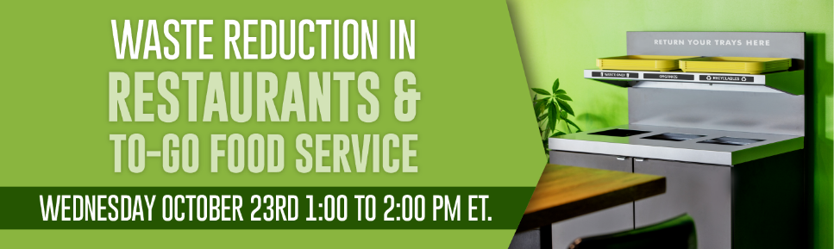
Webinar Chat Log
13:04:01 From Doreen S: Will this recorded webinar be available later on your website?
13:07:14 From Sean C: Hello Everyone, Sean Collins With SWACO, Please feel free to connect with me on LinkedIn!https://www.linkedin.com/in/sean-collins-7380529a/
13:09:42 From Alec Cooley: Yes, this program is being recorded. We will send an email tomorrow with a link view this.
13:16:58 From Waleria M: Do you have a record of how many containers are produced each year? Also, what is the return percentage?
13:17:50 From Stefanie P: I bet the return rate is hugely better because of the deposit scheme than programs without.
13:18:15 From Zoe B : Have you ever worked with food rescue organizations? We are currently working on diverting excess food from mall food court vendors and one of the large hurdles we are facing is businesses not wanting to pay the cost of to go packaging when donating their food.
13:18:16 From Betina P: What types of assurances do you provide regarding the cleanliness / sanitation of the returned and reused items, especially in light of new cleanliness standards post-Covid?
13:18:19 From Matthew P: How many users participated? Can you go over the container check out process once more? A deposit is applied at check-out, but is any registration involved?
13:19:45 From Kavi C: On that LCA chart 15-20 uses seems really low. I’ve seen similar charts from Upstream look at 500-1000 uses. What’s the average number of uses you see for your products?
13:20:56 From Nick M: Is 100% of the deposit returned to the consumer? Also is the container microwavable?
13:21:20 From Elizabeth B: How to you handle wear-and-tear on the containers over time?
13:21:31 From Nicole B: Any recommendations on return bin placement in larger campuses where "disposal" typically happens outside the food service venue?
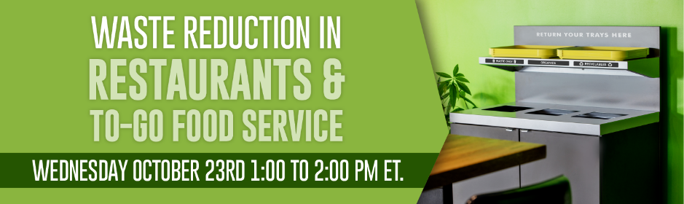
13:21:32 From Wren K: Listening for Tompkins County Recycling and Materials Management, based in Ithaca NY. Did you already have commercial sanitation facilites before you started?
13:21:32 From Betina P: What are Friendlier containers made of?
13:21:37 From Aaron C: Does the consumer scan the QR code or is this on behalf of the business supplying them? Is the scanning required?
13:21:40 From Angela P: In general how does the cost of the containers compare to compostable or other similar plastic containers?
13:21:58 From Mallika S: Typically how many items can a container be reused before it needs to be recycled? Are the containers be recycled at end of life?
13:22:04 From Connie L: Hello, Do you make your to go containers? What is the name brand? Who washes the dishes. Sorry if I missed this information.
13:22:44 From Tory R: Is there consideration to the chemical leaching from the plastic packaging when interacting with hot foods? Do consumers ever highlight this?
13:23:53 From Marika S: poll answer: The City of Victoria has a new bylaw that will require food and beverage businesses to use reusable food service ware for on-site dining There are over 40 of these policies in North America.
13:23:57 From Mary H: We have a green business program that tries to share information about reuse options with food service establishments and we have regulations that place limits on use of some single-use items.
13:25:01 From Lisa L: How many businesses and drop offs in your most popular city? How do you get businesses to participate. We find they dont have time to engage and are challenged by staff turnover
13:25:32 From Mary Katherine G: Businesses in Alameda County, CA can apply for reusable foodware infrastructure grants to help them make the switch. https://www.stopwaste.org/at-work/stopwaste-grants/grant-types/reusable-foodware-infrastructure-grants
13:26:05 From Dede A: Is this program offered to the states or only Canada? Would it be possible to ship the used containers back rather than have a pick up service?
13:26:33 From Mallika S: how many times do your products need to be reused to have a positive emissions footprint?
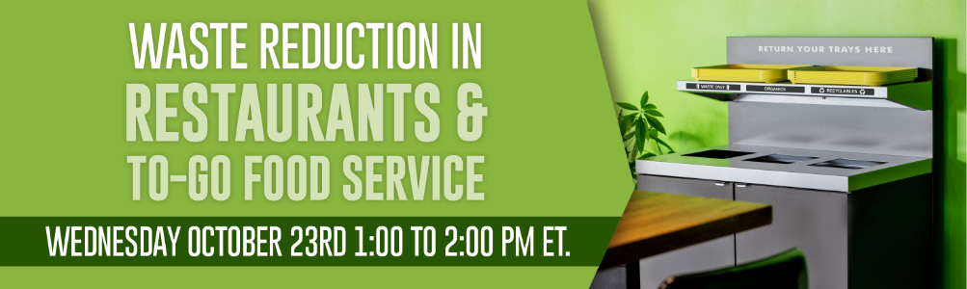

13:27:00 From Moji I: Seattle has a $500 incentive for purchasing reusables both for dine-in and for to-go! https://reuseseattle.org/reuse-rebate/
13:28:09 From Matthew P: San Francisco International Airport is designing its own internal reuse pilot for Airport food courts. Restaurants with their own seating use reusables.
13:28:10 From Stefanie P: @Mary - that grant cycle is currently closed. There are grants in Alameda County for dine-in reusables: https://www.stopwaste.org/reusables
13:29:27 From Mary Katherine G: The next cycle should be opening next Spring.
13:38:38 From Connie L: I am so happy to hear about this reduction of food being made! Wonderful!
13:40:16 From Daniel F: Offering up a new concept integrated reusable food container system that allows transport and delivery of food containers without a bag - eliminating that waste as well. Please feel free to take a look: www.turee.net and email me at dan@turee.net for questions and further info!☺️
13:41:20 From Connie L: Mary Katherine, I believe that grant has expired. Do you think they will do it again?
13:43:37 From Briana Z: How have restaurants reacted to advice to offer right-sized portions? I imagine some customers may not be happy given the "shrinkflation". Are restaurants also reducing menu pricing when they reduce portions?
13:48:19 From Zoe B: If anyone is interested in finding food rescue partners, Careit works all over the country and would love to help out! Feel free to check us out here: Careit.com or send me an email at Zoe@careit.com
13:49:31 From Briana Z: On the tax incentives - Do the restaurants you work with typically opt for the tax incentives or writing off the surplus (or wasted) food as a loss?
13:50:16 From Mary Katherine G: @Connie I believe so but I would reach out to them for details about the next cycle. info@stopwaste.org
13:57:14 From Stan U: Both slide presentations are very well done. Are they available for download?

13:57:53 From Frida P: How are "mixed dish" leftovers being tracked/audited? Ex. veggie noodle soup which may require multiple ingredients or a pasta dish which may require a mixed sauce made from scratch?
14:00:26 From Frida P: food waste in general
14:01:06 From Michele F: How can municipalities incentivize restaurants to consider these programs? They are concerned about the costs.
14:01:35 From Stefanie P: If restaurants stand to save so much (you said $7 for every $1 spent) what would you say is the biggest barrier to implementing the necessary steps?
14:05:17 From Shannon B : Thank you!
14:07:49 From Patsy B: Thank you all so much. This webinar was inspiring and interesting!
14:08:05 From Kevin M: Thank you!
14:08:07 From Elizabeth D: This was great! Thank you
14:08:25 From Frida P: Thank you!
14:08:32 From Selena L: Thank you
14:08:36 From Pui C: Thanks !
14:08:43 From Neree B: Thank you
14:08:47 From Waleria M: Thank you
14:08:48 From Jessica C: 👏
14:08:51 From Jake B: Thank you
14:09:28 From Ines S: Thank you! Both presentations were great!
14:09:57 From Daniel F: Excellent webinar thank you so much!
14:13:34 From Michele F: Thanks so much
14:22:51 From Connie L: Thank you Sarah
14:22:54 From James S: Thank you!

