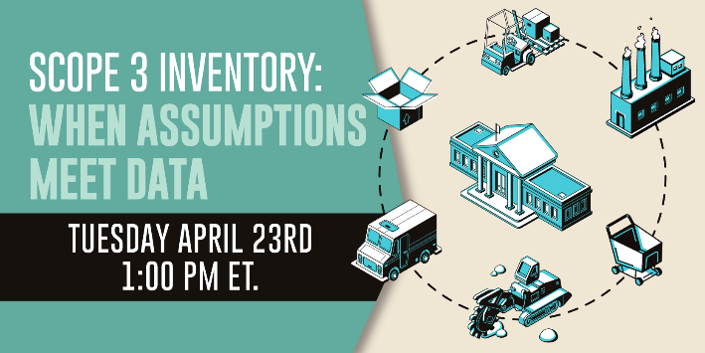
Webinar Chat Log

13:08:29 From Alec: Today's presentation slides and recording will be posted online to access in the coming days.
13:43:37 From Tyler: CAUBO (Canadian Association of University Business Officers) published a guide to help colleges and universities estimate and prioritize scope 3 emissions: https://tinyurl.com/5bdekwtk
13:44:28 From Tyler: AASHE has been organizing an ongoing workgroup of college & university sustainability managers focused on scope 3 emissions. You can find an archive of related resources and presentation recordings at: https://tinyurl.com/t38xr44v
13:46:50 From Tyler: CAUBO (Canadian Association of University Business Officers) published a guide to help colleges and universities estimate and prioritize scope 3 emissions: https://tinyurl.com/5bdekwtk
13:48:02 From Tyler: AASHE has been organizing an ongoing workgroup of college & university sustainability managers focused on scope 3 emissions. You can find an archive of related resources and presentation recordings at: https://tinyurl.com/t38xr44v
13:48:55 From Gary: CALL FOR PRESENTATIONS
The National Recycling Coalition (NRC) welcomes proposals for the 2024 National Recycling Congress on November 19, 2024. This will be a hybrid conference, conducted in person in Cooperstown, NY, and broadcast for virtual participation. The Theme for this Congress is “Climate, Circularity and Zero Waste.” We particularly seek leaders of climate change and circularity to highlight how they work to promote reduce, reuse, recycle, and compost programs and policies as part of their initiatives. Submissions are due by May 22, 2024. Call for Presentations link: https://lnkd.in/g2c7DC5m
13:50:11 From Tyler: Here’s the link to Alameda County’s Supply Chain Analysis report: https://www.acgov.org/sustain/what/purchasing/report.htm

14:00:19 From Tyler: Here are the links from Karen’s slide: Stop Waste Low Carbon Concrete Code: www.stopwaste.org/concrete and to County Performance Specification: https://www.acgov.org/sustain/what/greenbuilding/susdesign.htm
14:03:12 From Tyler: Here are links to the two organizations from Karen’s Resources slide - West Coast Climate and Materials Management Forum: https://westcoastclimateforum.com/cfpt ; and Sustainable Purchasing Leadership Council: https://www.sustainablepurchasing.org/. The other links from this slide will be included with the archived copy of Karen’s presentation at shared in the next few days.
14:10:27 From Tyler: Learn more about the carbon footprint of Busch System’s bin products at: https://www.buschsystems.com/carbon-footprint
14:12:52 From Tyler: Learn more about CarbonGraph at www.CarbonGraph.io
14:16:46 From Teresa: In my facility, MOST of our waste isn't really directly related to purchasing: it's mostly animal poop and plant trim!
14:25:17 From Teresa: page 21 here speaks to double counting: https://ghgprotocol.org/sites/default/files/2022-12/Scope%203%20Detailed%20FAQ.pdf
14:26:01 From Teresa: I also read this earlier in the week regarding double counting and found it really helpful: https://www.linkedin.com/pulse/why-double-counting-emissions-good-business-persefoni/
14:26:59 From Sahar: Thanks Teresa
14:28:47 From Tyler: You’ll be able to find all the resources mentioned today along with other Scope 3 emissions resources and the archived presentations. Look for an email to all registrants in the next few days.
14:29:40 From Tyler: Stay tuned for more information regarding our next webinar Making The Honor Role With K-12 Waste Reduction.
14:33:53 From Tyler: Learn more about the carbon footprint of Busch System’s bin products at: https://www.buschsystems.com/carbon-footprint

14:35:49 From Gary: which materials are best for low carbon?
14:36:05 From Sahar: Do the metal bins usually have higher impact?
14:36:30 From Gary: how do they compare to wood construction?
14:37:43 From Gary: thanks for doing this carbon analysis!
14:37:59 From Sahar: Thank you!

